🡪 use Zendb

🡪 db.createCollection("ZenPortal")

🡪 db.createCollection("Users")

🡪 db.createCollection("Tasks")

🡪 db.Users.insertMany([{ Stud_id: 1, Stud_name:"John", Mentor:"Stalin"}, {Stud_id: 2, Stud_name:"Joe", Mentor:"Stephen"},{Stud_id: 3, Stud_name:"Josh", Mentor:"Stalin"},{Stud_id: 4, Stud_name:"Adhi", Mentor:"Stalin"},{Stud_id: 5, Stud_name:"Anbu", Mentor:"Stalin"},{Stud_id: 6, Stud_name:"Anand", Mentor:"Stalin"},{Stud_id: 7, Stud_name:"Bala", Mentor:"Stalin"},{Stud_id: 8, Stud_name:"Cathrine", Mentor:"Stalin"},{Stud_id: 9, Stud_name:"Deepa", Mentor:"Stalin"}, {Stud_id: 10, Stud_name:"Ezhil", Mentor:"Stalin"},{Stud_id: 11, Stud_name:"Fahad", Mentor:"Stalin"},{Stud_id: 12, Stud_name:"Henry", Mentor:"Stalin"},{Stud_id: 13, Stud_name:"Ishwarya", Mentor:"Stalin"},{Stud_id: 14, Stud_name:"Kalyan", Mentor:"Stalin"},{Stud_id: 15, Stud_name:"Lal", Mentor:"Stalin"},{Stud_id: 16, Stud_name:"Mahi", Mentor:"Stalin"},{Stud_id: 17, Stud_name:"Noorjagan", Mentor:"Stalin"}])

1.db.Tasks.find({"Date": {"$gte": ("01/10/2020"),"$lte": ("31/10/2020")}},{"Topic_Covered": 1,"Tasks": 1,"_id": 0})

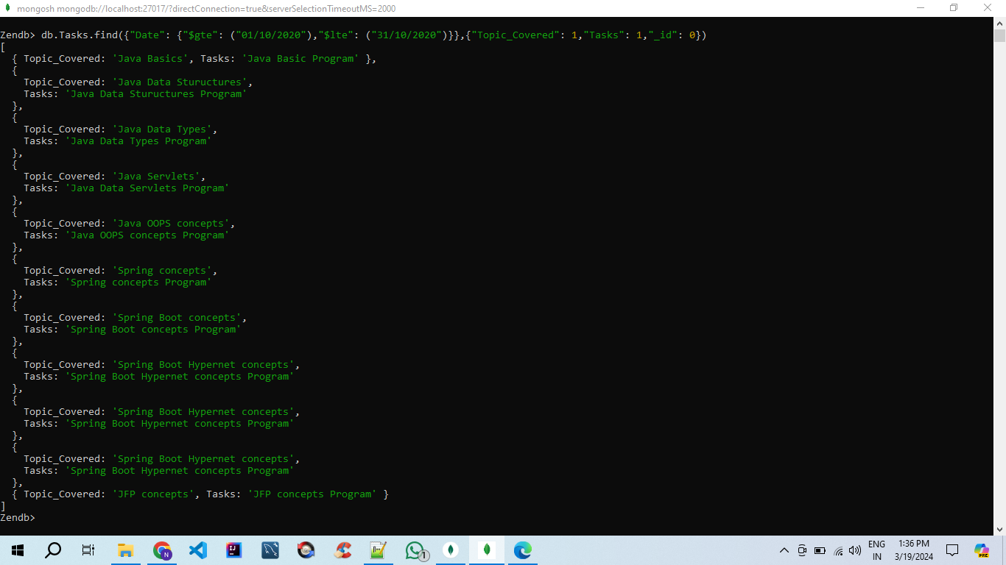

2.db.Tasks.find({"Date":{"$gte":"15/10/2020","$lte":"31/10/2020"}},{"Company_Visited" :1,"_id":0})

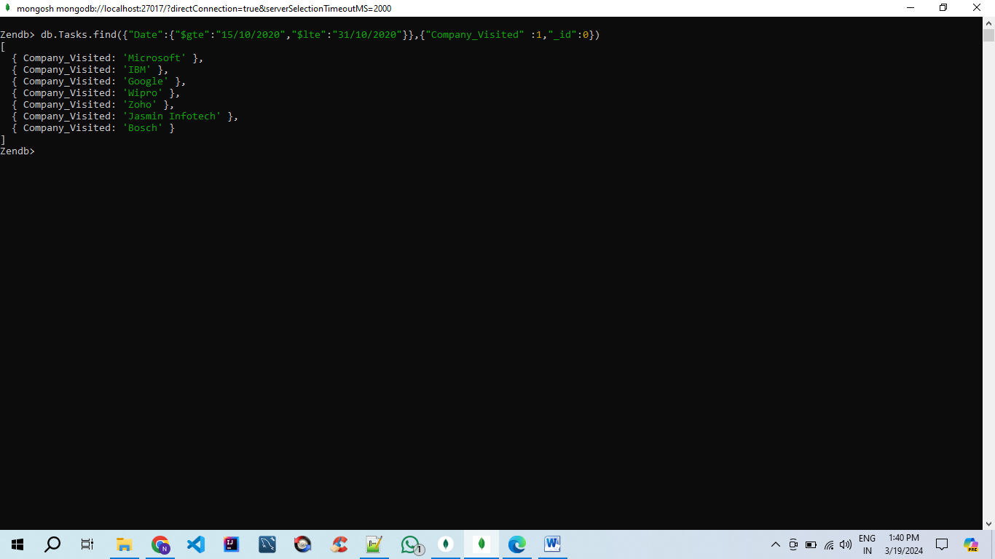

3. db.Tasks.aggregate([{$unwind: "$Attended_Students"},{$group: {_id: "$Company_Visited",Students: { $addToSet: "$Attended_Students" }}}])

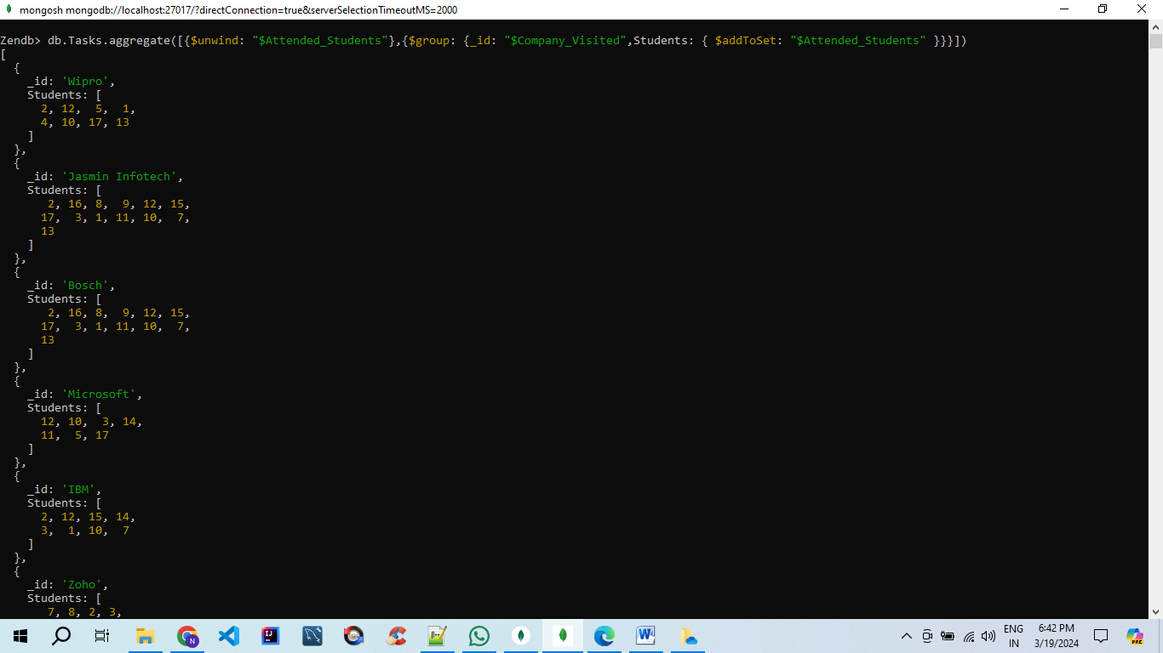



4.db.Attendance.aggregate([{$group: {_id: "$Stud_id",total_problems_solved: { $sum: "$Codekata" }}},{$project: {Stud_id: "$_id",total_problems_solved: 1, _id: 0}}])

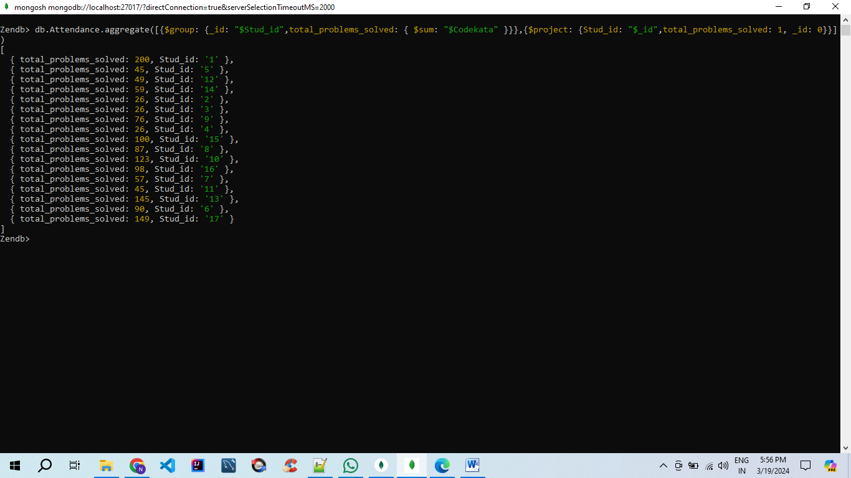

5.db.Users.aggregate([{$group: {_id: "$Mentor", menteeCount: { $sum: 1 }}},{$match: {menteeCount: { $gt: 15 }}}])

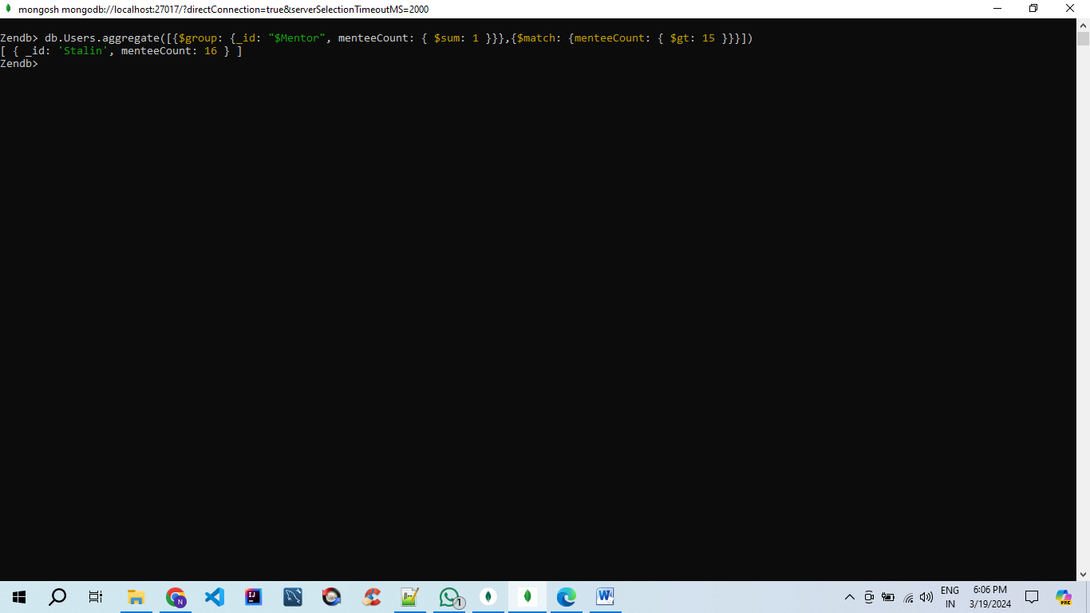

6.db.Attendance.aggregate([{$match: {"Attendance.Date": {$gte: "15/10/2020",$lte: "31/10/2020"},"Attendance.Status": "Absent","Attendance.Task Submitted": "No"}},{$group: {_id: "$Stud_id"}},{$count: "numAbsentNoTask"}])

